**< Gravity to Electricity Concept >**

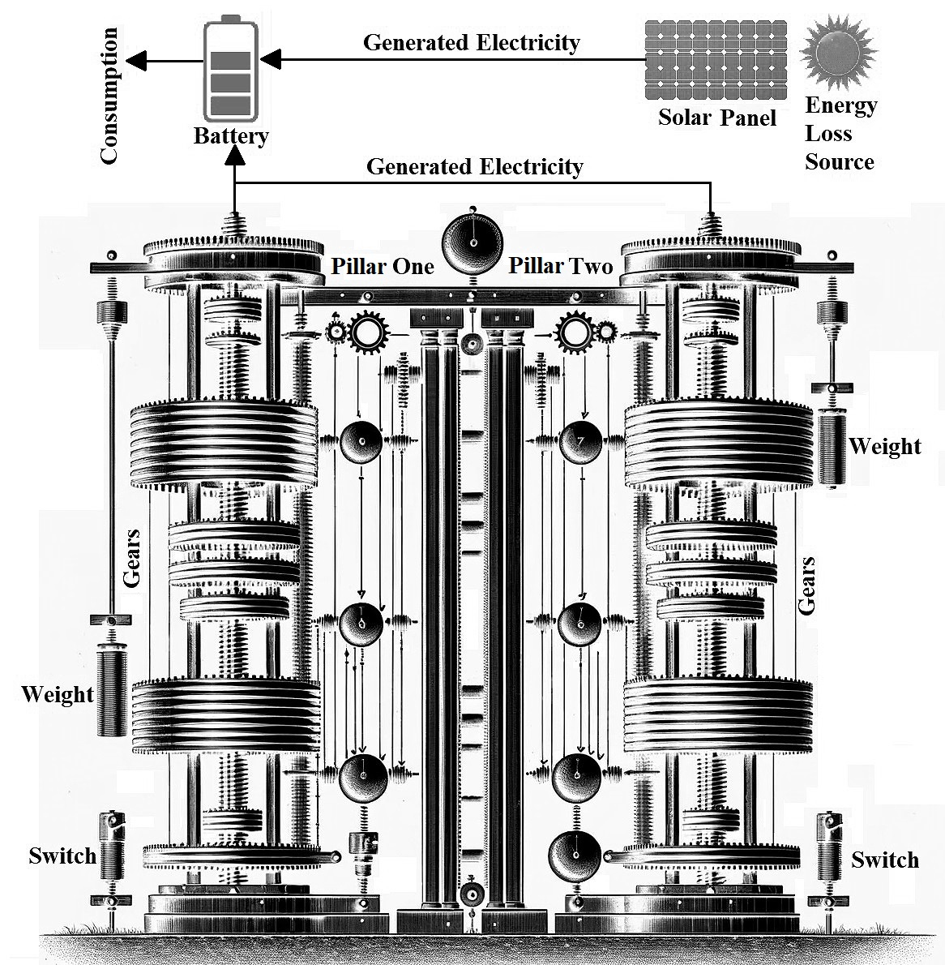The base concept is to convert gravity to electricity by using gears and weights. The main goal is to provide an unlimited source of energy for everyone around the globe, **equally and almost free**. The figure depicts this concept. The concept is as follows. There are two pillars of connected gears and each one of them is connected to a weight. Gravity pulls down one weight which causes one pillar of gears to spin and produce electricity. When the weight reaches the floor, it triggers a switch on the floor under the weight which activates the other weight belonging to the other pillar of gears and pulls up the initial weight. This would be an unstoppable loop. However, the concept of generating unlimited energy using only weights and gears without any loss or input of energy would **violate the first and second laws of thermodynamics [1 - 4]**, which are fundamental principles in physics**. First Law of Thermodynamics (Law of Energy Conservation) [1 – 4]**: This law states that energy cannot be created or destroyed, only transformed from one form to another. In any closed system, the total energy remains constant. Thus, to lift the weights after they have fallen and generated electricity, it is needed to input at least as much energy as it gained from them falling. **Second Law of Thermodynamics [1 – 4]**: This law states that in any energy transfer or transformation, some amount of energy is dissipated as waste heat due to inefficiency. This increases the entropy of the system. In practical terms, it means it is not possible to have 100% efficient energy conversion, and over time, some energy is always lost to the surroundings.

Now, the question is how the energy for pulling up the weight will be generated. This could be done by any renewable energy sources. Here, the solar panel is selected as it is available almost everywhere. The solar panel is connected to the power storage (battery) for resetting the process. Also, gears are connected to the battery to transfer the generated electricity for later usage. Clearly, the process of converting mechanical energy from spinning gears into electrical energy is typically done using a generator which is called "electromagnetic induction."

**Energy Conversion Principles [5 – 9]** - > **Gravitational Potential Energy (GPE)**: The GPE of the weights is converted to kinetic energy as they fall, which is then converted to electrical energy by the gear system. The GPE is given by the equation: ***GPE = mgh***. where: m is the mass of the weight, g is the acceleration due to gravity (9.81 m/s^2 on Earth), h is the height from which the weight falls. **Kinetic Energy (KE)**: As the weight falls, its potential energy is converted into kinetic energy, which can be calculated with ***KE = 1/2 mv^2***. where: v is the velocity of the weight. **Energy Conversion Efficiency**: Not all the gravitational energy will be converted into electrical energy due to inefficiencies in the system (friction in the gears, air resistance, etc.). If η represents the efficiency of the system, the actual electrical energy (E_elec) obtained can be expressed as: ***E_elec = η*** ***⋅ GPE***. **Mechanical Work**: The work done by the gear system in lifting the weight can be described by: ***W = Fd***. where: F is the force applied by the gear system, d is the distance over which the force is applied (equivalent to h in the absence of friction). **Solar Power Input**: The solar panels provide energy to lift the weights. The power output of the solar panels can be calculated by: ***P_solar = A ⋅ G ⋅ η_solar***. where: A is the area of the solar panels, G is the solar irradiance (the power per unit area received from the Sun), η_solar is the efficiency of the solar panels. **Energy Storage**: The energy stored in the battery can be calculated with: ***E_stored = Vit***. where: V is the voltage of the battery, I is the current, t is the time for which the current flows. **System Dynamics**: The cyclical operation of the system will require dynamic equations that take into account the time it takes for each weight to fall, the time for the solar panels to lift the weight, and the discharge rate of the battery. **Control System**: A control system would be needed to switch the weights and manage the flow of energy. This would involve feedback loops and possibly programmable logic controllers (PLCs). **Electrical Circuit Equations**: Ohm's Law and Kirchhoff's circuit laws would govern the electrical flow: ***V = IR. ∑V_in = ∑V_out.***

**Benefits - > Renewable Energy Source**: Using gravity to generate electricity is renewable, as it relies on the Earth's gravitational field, which is constant and inexhaustible. **Low Operating Costs**: Once the system is set up, the cost of maintaining it is relatively low compared to the costs of fuel-based power generation. **Environmentally Friendly**: This system does not emit greenhouse gases or pollutants, making it a clean energy source. **Scalability**: The concept can potentially be scaled to different sizes, making it suitable for a range of applications, from small installations to larger power plants. **Storage of Energy**: The system can act as a form of energy storage. Weights can be lifted when excess energy is available (for example, when demand is low or when renewable sources like wind or solar are producing more electricity than needed) and then released to generate electricity when demand is higher. **Complementary to Other Renewables**: It can complement other forms of renewable energy, like solar or wind, by providing energy when those sources are not available. Drawbacks - > **Energy Input Required**: The system requires a constant input of energy to lift the weights against gravity. If this energy is not sourced from renewables, it could negate the environmental benefits. **System Efficiency**: No system is 100% efficient. Energy losses due to friction in the gears and air resistance will occur, meaning that the system cannot generate as much electricity as the energy used to lift the weights unless supplemented by another energy source like solar panels. **Physical Limitations**: The height from which the weights can fall, and thus the amount of gravitational energy that can be converted, is limited by the physical construction of the system and the space available. **Material Wear and Tear**: Moving parts like gears and weights will wear out over time, requiring maintenance and eventual replacement. **Initial Costs**: The upfront cost for constructing such a system, including the gears, weights, structure, and control systems, can be a bit substantial (but not in mass production). **Energy Density**: The energy density (energy per unit volume) for gravitational energy is low compared to chemical energy sources like fossil fuels or nuclear power, meaning more space is needed for the same amount of energy production.

1. *Swaney, Ross E., and R. Byron Bird. "The first and second laws of thermodynamics." Physics of Fluids 31.9 (2019).*
2. *Boltzmann, Ludwig. "The second law of thermodynamics." Theoretical physics and philosophical problems: selected writings. Dordrecht: Springer Netherlands, 1974. 13-32.*
3. *Lewis, Gilbert Newton, and Merle Randall. Thermodynamics. No. 44. Krishna Prakashan Media, 1963.*
4. [*https://chem.libretexts.org/Courses/Bennington_College/Chemistry_-_An_Integrated_Approach_(Bullock)/03%3A_Why_Do_Molecules_Exist/3.04%3A_The_First_and_Second_Laws_of_Thermodynamics*](https://chem.libretexts.org/Courses/Bennington_College/Chemistry_-_An_Integrated_Approach_(Bullock)/03%3A_Why_Do_Molecules_Exist/3.04%3A_The_First_and_Second_Laws_of_Thermodynamics)
5. *Culp Jr, Archie W. "Principles of energy conversion." (1991).*
6. *Ghosh, Attreyee, William E. Holt, and Lucy M. Flesch. "Contribution of gravitational potential energy differences to the global stress field." Geophysical Journal International 179.2 (2009): 787-812.*
7. *Wang, Lin-Wang, and Michael P. Teter. "Kinetic-energy functional of the electron density." Physical Review B 45.23 (1992): 13196.*
8. *Landsberg, P. T., and G. Tonge. "Thermodynamic energy conversion efficiencies." Journal of Applied Physics 51.7 (1980): R1-R20.*
9. *Naing, Lin Phyo, and Dipti Srinivasan. "Estimation of solar power generating capacity." 2010 IEEE 11th International Conference on Probabilistic Methods Applied to Power Systems. IEEE, 2010.*